One day workshop on “FRONT-END WEB DEVELOPMENT & WEB HOSTING”
Date and Venue: 26th November, 2022 at Auditorium, Pub Kamrup College
Resource Person:
- Mr. Dibyajyoti Changkakati, Head Coding Coach of Ujucode, Google Educator, Artificial Intelligence Expert
- Jayant Siktia, Co-founder, Ujucode
Participants: 187 nos. (Teachers and Students)
Some Photo clicks:
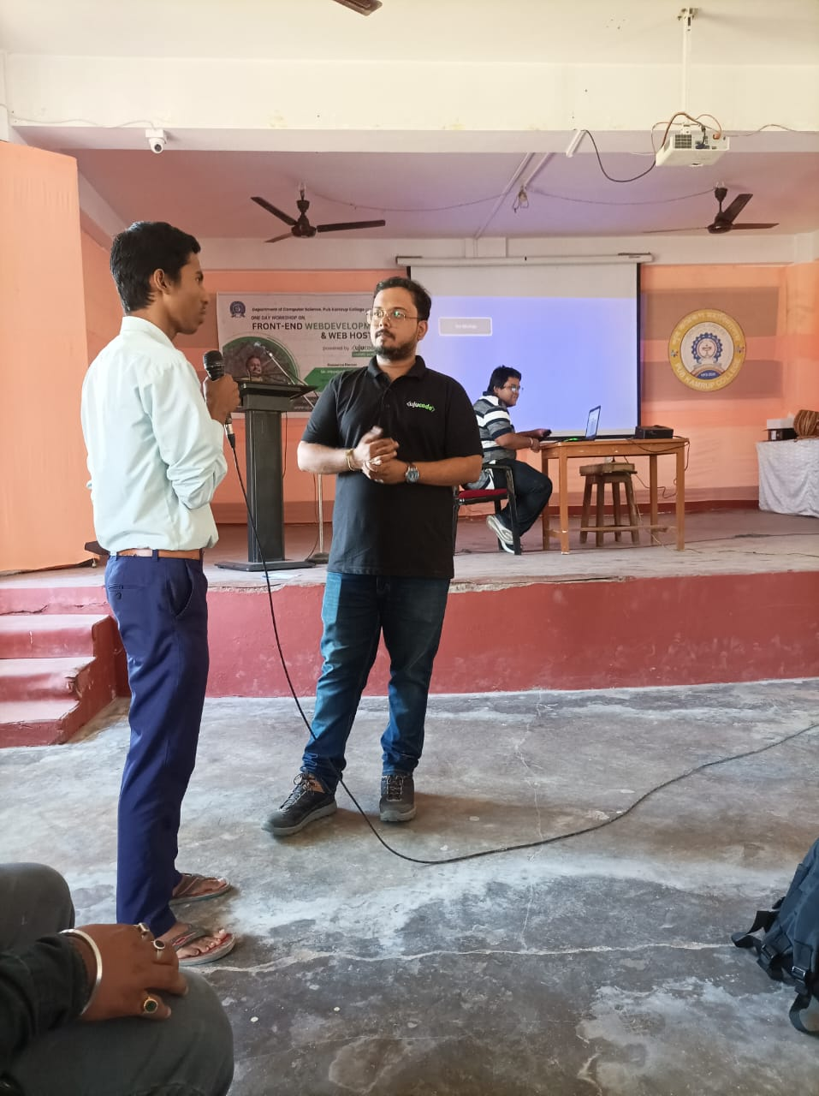
A moment of interaction with students
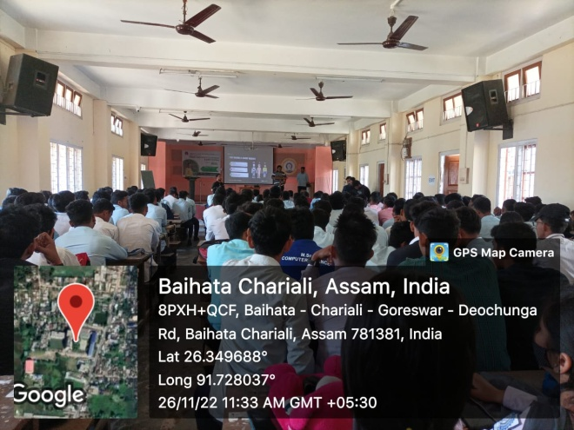
An overview of the student participants
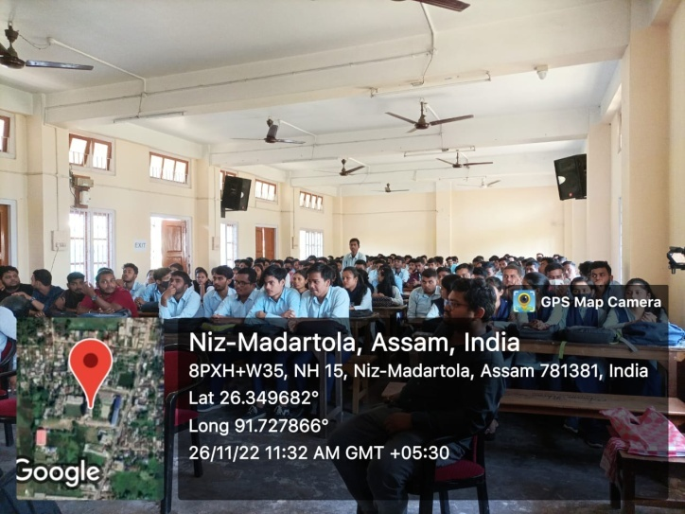
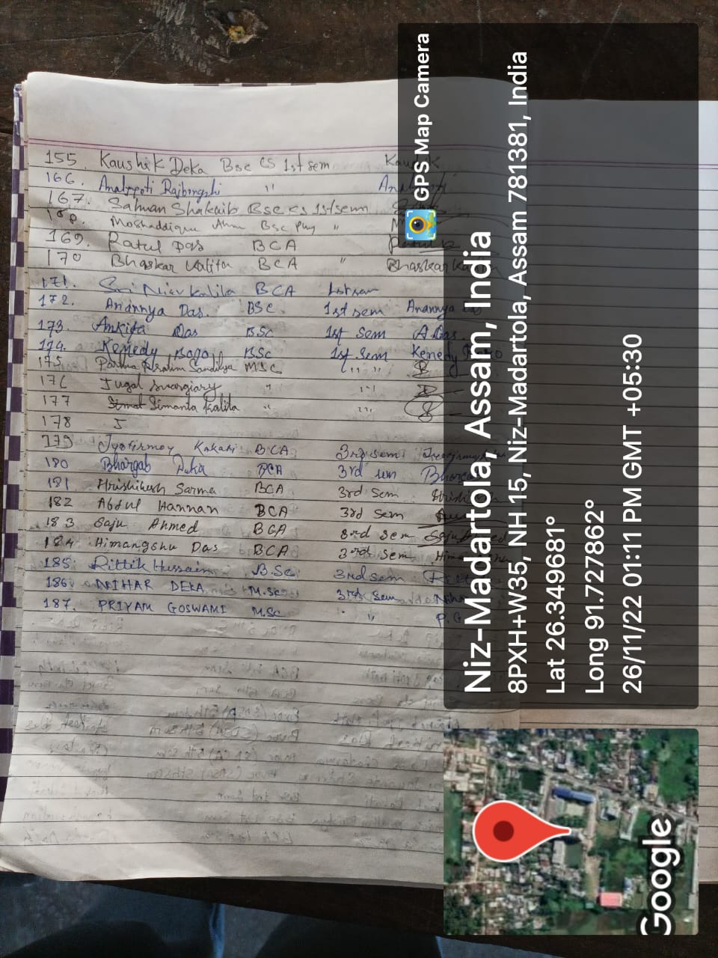
Signature of student participants
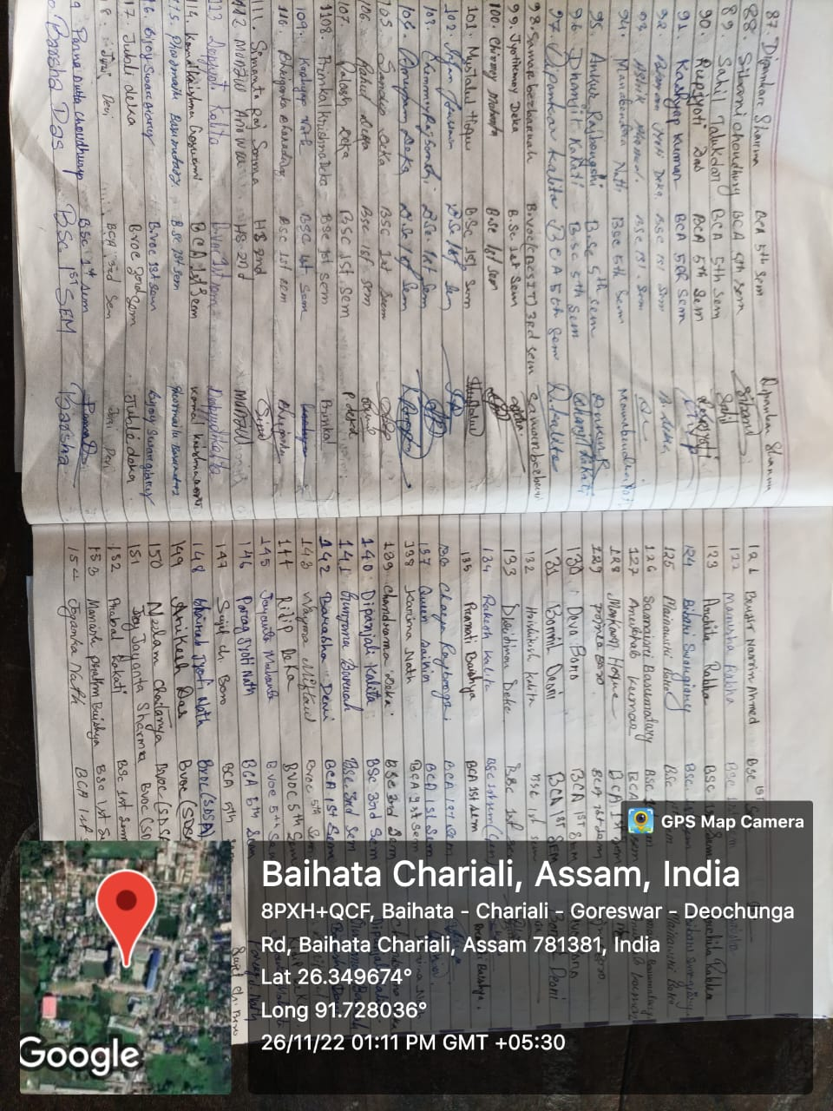

Signature of student participants
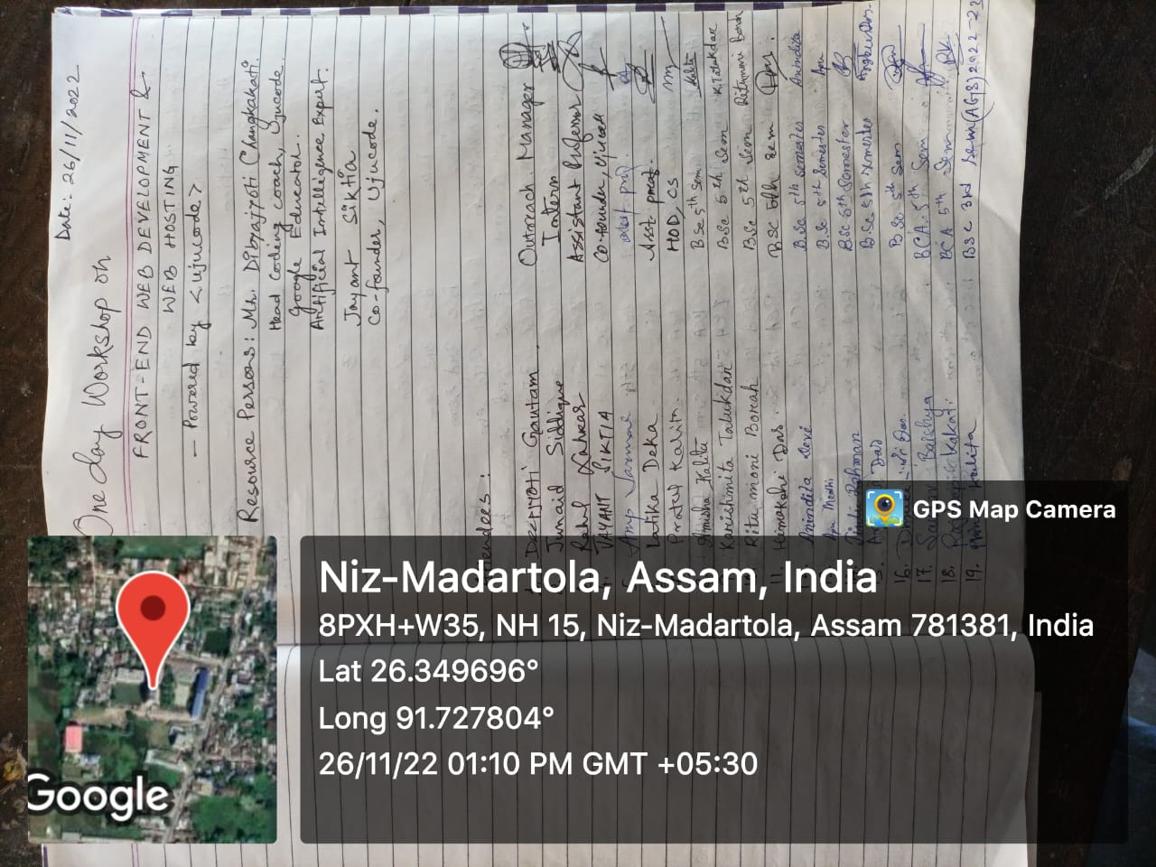
Signature of student participants
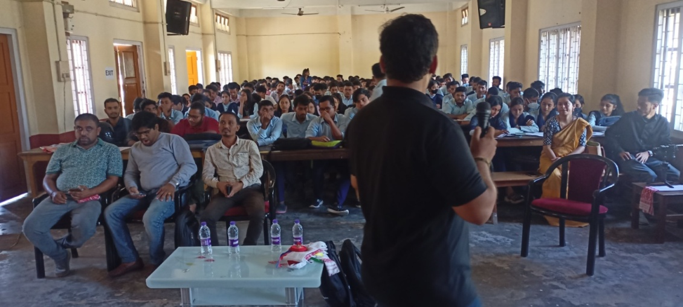
Dr Dibyajyoti delivering lecture

